A Project Report

on

MOVIE RECOMMENDATION SYSTEM
carried out as part of the PBL-1 (INT2170) Submitted

by

Pranava Adithyaa
2430030089

in partial fulfilment for the award of the degree of

Bachelor of Technology

in

Information Technology

Under the Guidance of
Guide Name



Department of Information Technology

MANIPAL UNIVERSITY JAIPUR
RAJASTHAN, INDIA

Nov 2025

ABSTRACT

In the modern digital streaming era, users are presented with a "paradox of choice," where the sheer volume of available movies on platforms like Netflix and Amazon Prime leads to decision fatigue and difficulty in discovering new, relevant content. This project directly addresses this present-day scenario by building a practical solution. The objective is to design, develop, and test a Content-Based Filtering recommender system that provides users with personalized movie suggestions based on the intrinsic properties of the movies themselves.

The methodology adopted involved a complete, end-to-end machine learning pipeline. Two large datasets from TMDB (containing movie details and credits) were acquired, cleaned, and merged using the Pandas library. A "tags" feature was engineered by combining key text data, including plot overview, genres, keywords, cast, and crew. This text data was then converted into a high-dimensional numerical vector space using scikit-learn's CountVectorizer. The cosine_similarity metric was applied to this matrix to calculate the similarity between all movies. The significant result is a fully functional prototype web application built with Streamlit, which loads the pre-computed model and provides real-time, accurate movie recommendations to a user.

LIST OF FIGURES

Figure No | Figure Title | Page No
3.21 | Homepage | 4
3.22 | Example Search | 4

TABLE OF CONTENTS

S. No | Content | Page No
1 | Introduction | 1
1.1 | Introduction (Overview) | 1
1.2 | Problem Statement | 1
1.3 | Objectives | 1
1.4 | Scope of Project | 1
2 | Proposed System Design & Methodology | 2
2.1 | System Architecture | 2
2.2 | Development Environment (H/w & S/W) | 2
2.3 | Methodology: Algorithm/Procedures | 3
3 | Work Done in PBL-1 | 4
3.1 | Tasks achieved so far | 4
3.2 | Screenshots / sketches / circuit diagram / flow diagrams | 4
4. | Conclusion and Future Plan | 5
5. | References | 6
6 | APPENDIX | 7
6.1 | Snippet- Vectorization and Similarity Calculation | 7
6.2 | Core recommendation function and streamlit application | 7

1.Introduction

1.1. Introduction (Overview, Motivation, Applications & Advantages)
This project is an end-to-end implementation of a content-based movie recommender system. The primary motivation stems from a common, modern-day problem: the "paradox of choice." While streaming services provide unprecedented access to thousands of movies, this vast selection often overwhelms users, making it difficult to find new movies they will genuinely enjoy. This leads to user frustration and reliance on generic "trending" lists.
A personalized recommender system solves this by acting as an intelligent filter. The key application is to enhance the user experience on media platforms. The main advantage of the content-based approach chosen for this project is its simplicity and transparency. It does not require data from other users (which avoids the "cold start" problem for new items) and recommends movies based on their inherent, understandable properties (e.g., same director, similar plot keywords, or same actors).

1.2. Problem Statement
The core problem is the overwhelming cognitive load placed on users of modern streaming platforms due to the sheer volume of available content. This "information overload" makes it difficult and time-consuming for a user to discover new movies that align with their specific tastes. This project aims to design and build a functional web application that solves this problem by providing fast, accurate, and personalized movie recommendations based on a user's stated preference for a single movie.

1.3. Objectives
The primary objectives for this phase of the project were as follows:
1. Data Processing: To load, clean, and merge two large movie datasets (the TMDB 5000 movie and credits files).
2. Feature Engineering: To create a unified "tags" feature by combining a movie's overview, genres, keywords, cast, and crew into a single, comprehensive text block.
3. Model Building: To transform the text "tags" into a numerical vector space using CountVectorizer and then calculate the similarity between all movies using cosine_similarity.
4. Application: To build an interactive web app (using Streamlit) that loads the pre-computed model and provides real-time recommendations to a user.

1.4. Scope of Project
The scope of this project is strictly defined as a Content-Based Filtering system. The recommendation logic is based only on the intrinsic properties of the movies themselves (plot, cast, crew, etc.). This project does not include Collaborative Filtering, which is a different methodology based on user ratings and behaviour. The final deliverable for this phase (PBL-1) is a functional, local prototype. Deployment to a public web server and exploration of other filtering methods (like TF-IDF or Collaborative) are designated as future work.

1
2.Proposed System Design & Methodology

2.1. System Architecture
The project follows a six-step data pipeline, which serves as the system architecture. This flow describes the process from raw data to a functional application:
Input: The process begins by loading the two raw datasets, movies.csv and credits.csv, into Pandas DataFrames.
- Preprocessing: The two DataFrames are merged on the 'title' column. Any rows with missing data (null values) are dropped. Helper functions are used to parse the JSON-like string columns (e.g., cast, crew, genres) and extract only the relevant names (e.g., "Tom Hanks" from the cast column).
- Feature Engineering: A new column, tags, is created. This column is the most critical feature, formed by concatenating all the cleaned text data for each movie (overview, genres, keywords, top 3 cast members, and director).
- Vectorization: The entire tags corpus is fed into a CountVectorizer (from scikit-learn) with max_features=5000. This process converts each movie's tags into a 5000-dimension numerical vector, where each dimension represents the count of a specific word.
- Modeling: The cosine_similarity metric is applied to the vectorized data. This calculates a similarity score (from 0 to 1) for every movie against every other movie, resulting in a large similarity matrix.
- Output: The final processed DataFrame (containing movie IDs and titles) and the similarity matrix are saved as .pkl files using the pickle library. The Streamlit app loads these files directly to make predictions.
2.2. Development Environment (H/w & S/W)
- Hardware (H/W):
    - Machine: Windows 11 Laptop
    - CPU: Intel Core i5 (or equivalent)
    - RAM: 8GB
- Software (S/W):
    - Core: Python 3.10
    - Environment: venv (Python Virtual Environment)
    - IDE: Visual Studio Code, Jupyter Notebook
    - Key Libraries:
    - pandas & numpy (For data manipulation)
    - scikit-learn (For ML model)
    - streamlit (For the web application)
    - pickle (For saving/loading the model)
    - requests (For fetching API data)

2

2.3. Methodology: Algorithm/Procedures

Methodology: Content-Based Filtering This project employs a Content-Based Filtering methodology. This method recommends items based on their intrinsic properties. It does not rely on other users' ratings or behaviour. For example, if a user likes The Avengers because its properties include "superhero," "action," and "Chris Evans," the system will recommend other movies that share those same properties, such as Iron Man or Captain America.

Algorithm 1: CountVectorizer (Text Vectorization) To perform mathematical calculations on text data, it must first be converted into a numerical format. CountVectorizer is a technique used to tokenize a collection of text documents and build a vocabulary of the most common words (limited to 5000 in this project). It then creates a matrix where each row is a movie, and each column is a word from the vocabulary. The value in each cell is the count of how many times that word appeared in that movie's tags. This is also known as a "Bag of Words" model.

Algorithm 2: cosine_similarity (Similarity Metric) After vectorization, each movie is represented as a high-dimensional vector. cosine_similarity is a mathematical formula that measures the cosine of the angle between two of these vectors. It is a highly efficient way to determine similarity, especially in high-dimensional spaces. A score of 1 means the vectors are identical (and the movies are very similar), while a score of 0 means the vectors are completely different (and the movies are dissimilar). The system uses this to find the 5 highest-scoring movies.

3

3. Work Done in PBL-1
3.1. Tasks achieved so far
- Requirement Gathering: Successfully acquired the TMDB 5000 dataset from Kaggle, which formed the basis of the project.
- Data Preprocessing: Successfully loaded, cleaned, and merged the movies and credits datasets into a single, usable DataFrame, handling complex JSON data embedded in the CSVs.
- Model Design: Engineered the tags feature and selected CountVectorizer with cosine_similarity as the core recommendation logic.
- Model Training: Built and tested the complete recommendation logic in a Jupyter Notebook, culminating in the creation of the movies_list.pkl and similarity.pkl model files.
- Application Prototyping: Built a functional, local web application using Streamlit that and displaying movie posters from the TMDB API.

3.2 Screenshots / sketches / circuit diagram / flow diagrams

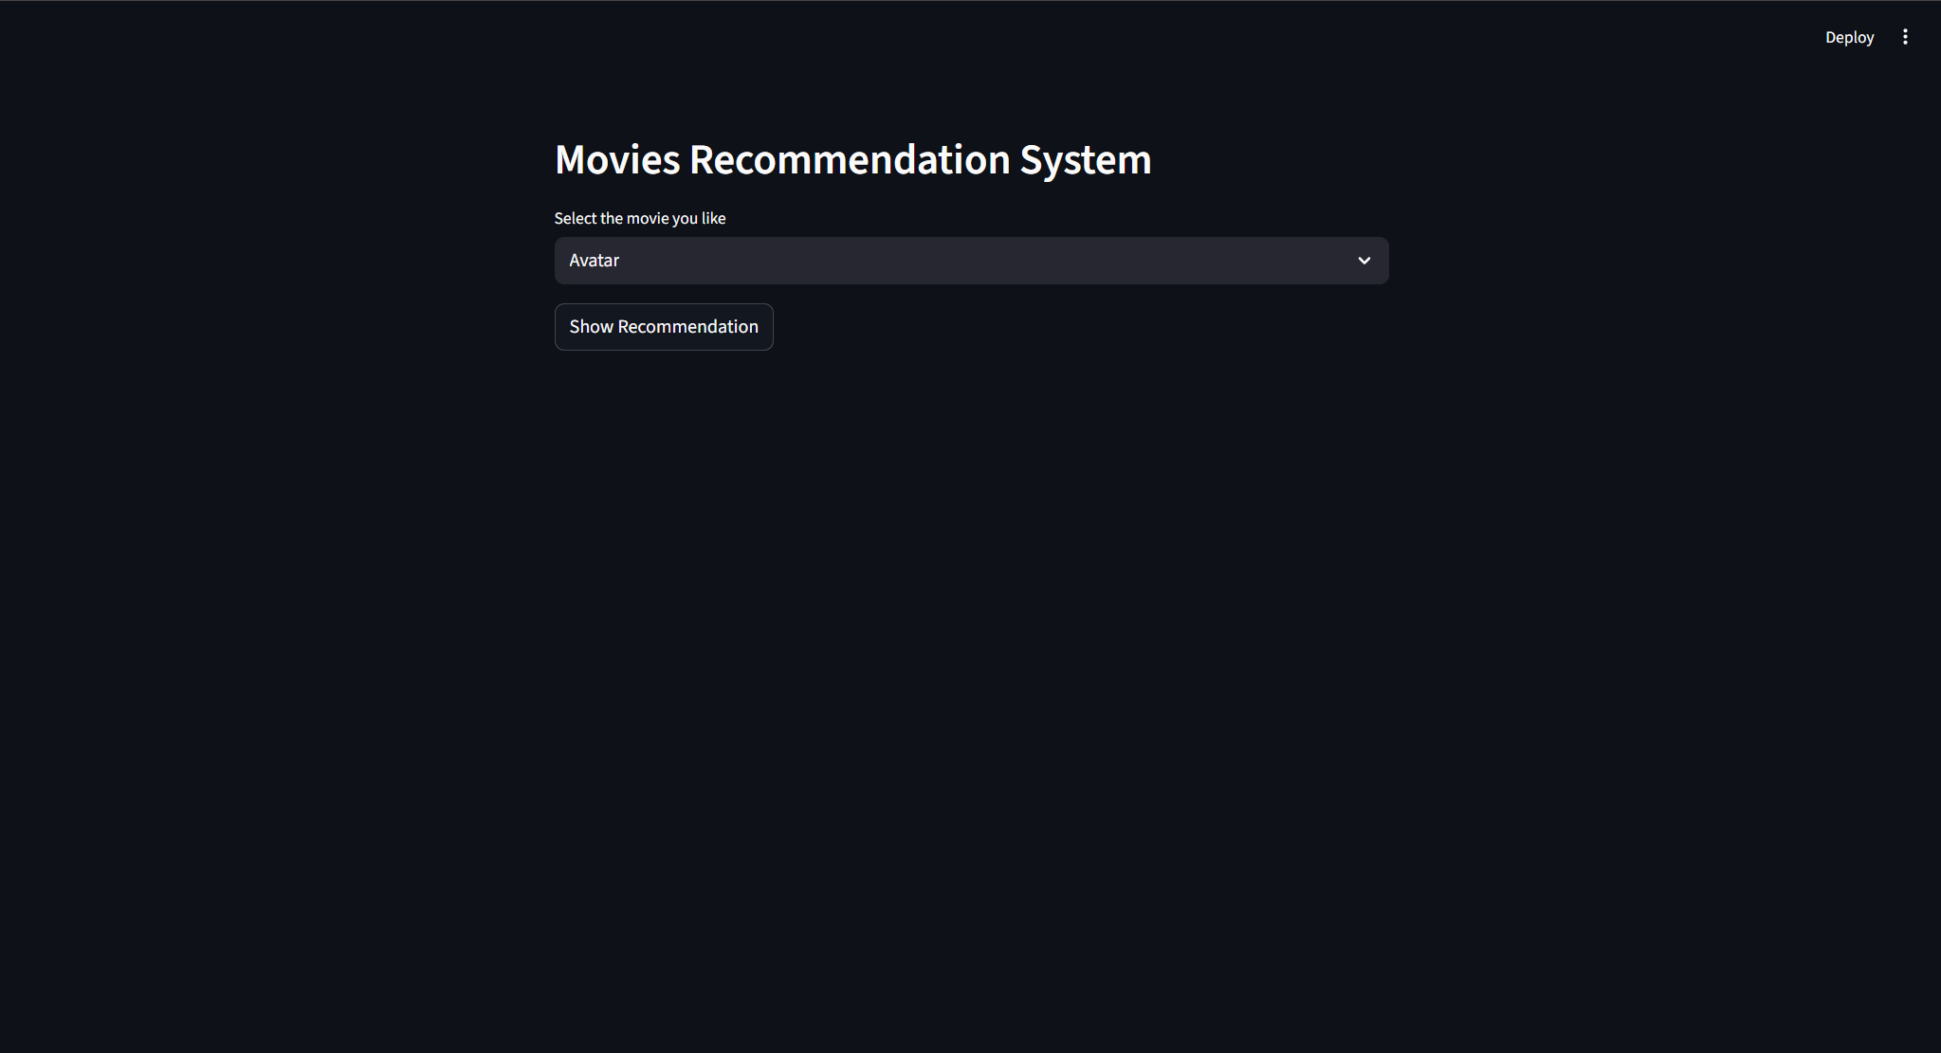
3.21-Homepage

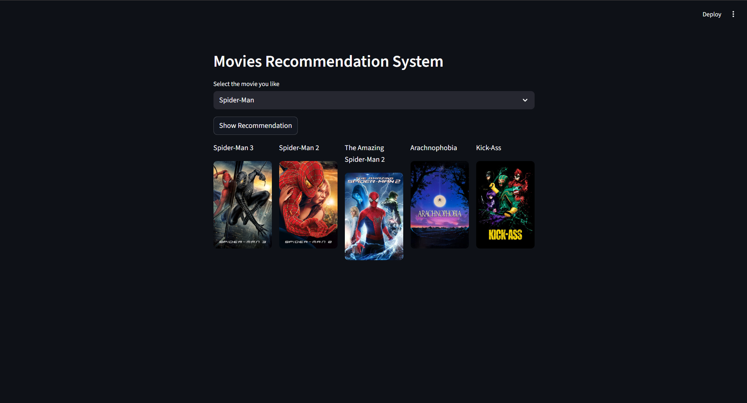
3.22-Example search 4

4.Conclusion and Future Plan

This project successfully achieved all its initial objectives, resulting in a complete, end-to-end machine learning project. A stable prototype application was built, progressing from raw, messy data to a fully functional, interactive local web application. The final product provides accurate movie recommendations based on content similarity, establishing a strong foundation in data preprocessing, text vectorization, and building ML-powered web apps with Streamlit. The process also highlighted and solved common development challenges, including environment management (venv), file path errors (FileNotFoundError), and library dependency issues.

The plan for immediate future work is to build upon this successful prototype. The highest priority is to deploy the Streamlit app online using Streamlit Community Cloud, which will make the project publicly accessible and complete the development cycle. Concurrently, the model itself will be improved by experimenting with TF-IDF vectorization instead of CountVectorizer. TF-IDF (Term Frequency-Inverse Document Frequency) may yield better results by prioritizing unique, important keywords. The application's user experience will also be enhanced by using the TMDB API to make the movie posters clickable, leading to an official page or a trailer.

Looking further ahead, the long-term vision is to evolve this project into a more sophisticated Hybrid Recommender System. This would involve implementing a second model based on Collaborative Filtering, which analyzes user ratings and behaviour. By combining the strengths of both Content-Based (which we have now) and Collaborative (which analyzes what other similar users like) filtering, the system could provide even more accurate and personalized recommendations, addressing the weaknesses of each individual approach.

5

5. References

[1] "TMDB 5000 Movie Dataset," Kaggle, 2017. [Online]. Available: https://www.kaggle.com/datasets/tmdb/tmdb-movie-metadata. [Accessed: Nov. 14, 2025].

[2] DSwBappy, "Movie Recommender System | Machine Learning," YouTube, 2023. [Online]. Available: https://www.youtube.com/playlist?list=PLkz_y24mlSJYWa_JEjptWvwXToNNXIXOp. [Accessed: Nov. 14, 2025].

[3] P. Pedregosa et al., "Scikit-learn: Machine Learning in Python," Journal of Machine Learning Research, vol. 12, pp. 2825-2830, 2011.

6

6. APPENDIX

6.1 Snippet- Vectorization and Similarity Calculation:

from sklearn.feature_extraction.text import CountVectorizer
cv = CountVectorizer(max_features=5000, stop_words='english')
vector = cv.fit_transform(new_df['tags']).toarray()
from sklearn.metrics.pairwise import cosine_similarity
similary = cosine_similarity(vector)

6.2 Core recommendation function and streamlit application:

import pickle
import streamlit as st
import requests
def fetch_poster(movie_id):
url="https://api.themoviedb.org/3/movie/{}?api_key=d2e9d4ee27c0d9b29bae86068eae7a86".format(movie_id)
response = requests.get(url)
data = response.json()
poster_path = data['poster_path']
full_path = "https://image.tmdb.org/t/p/w500/" + poster_path
return full_path
def recommend(movie):
index =movies[movies['title']] == movie.index[0]
distances = sorted(list(enumerate(similarity[index])), reverse=True,key= lambda x: x[1])
recommended_movies_name = []
recommended_movies_posters = []
for i in distances[1:6]:
movie_id = movies.iloc[i[0]].movie_id
recommended_movies_name.append(movies.iloc[i[0]].title)
recommended_movies_posters.append(fetch_poster(movie_id))
return recommended_movies_name, recommended_movies_posters
st.header("Movies Recommendation System")
movies = pickle.load(open('artifacts/movie_list.pkl', 'rb'))
similarity = pickle.load(open('artifacts/similarity.pkl', 'rb'))
movies_list = movies['title'].values
selected_movie = st.selectbox('Select the movie you like', movies_list)

7

if st.button('Show Recommendation'):
recommended_movie_names, recommended_movie_posters = recommend(selected_movie)
col1, col2, col3, col4, col5 = st.columns(5)
with col1:
st.text(recommended_movie_names[0])
st.image(recommended_movie_posters[0])

with col2:
st.text(recommended_movie_names[1])
st.image(recommended_movie_posters[1])
with col3:
st.text(recommended_movie_names[2])
st.image(recommended_movie_posters[2])
with col4:
st.text(recommended_movie_names[3])
st.image(recommended_movie_posters[3])
with col5:
st.text(recommended_movie_names[4])
st.image(recommended_movie_posters[4])

8

